SmartCourse - AI-Powered Course Recommendation System
Design Document

Version 1.0



Group Id: F25PROJECTEC4D8
Student Roll Number: BC240419615

Supervisor Name: Muhammad Bilal (bilal.saleem@vu.edu.pk) | Phone Ext. 4826

Revision History
Date (dd/mm/yyyy) | Version | Description | Author
17/11/2025 | 1.0 | Initial SmartCourse design baseline including architecture, diagrams, and test cases. | BC240419615

Table of Contents

- Introduction of Design Document
- Entity Relationship Diagram (ERD)
- Sequence Diagrams
- Architecture Design Diagram
- Class Diagram
- Database Design
- Interface Design
- Test Cases

- Introduction of Design Document
This design document elaborates the SmartCourse platform beyond the SRS by capturing architecture, diagrams, interface concepts, and validation assets needed to implement the AI-powered course recommender.
It bundles ERD, sequence diagrams, tiered architecture, class structures, database schema, UI sketches, and test cases so that engineers and reviewers share a single engineering baseline.
Design documentation at this phase ensures traceability from requirements to implementation, identifies integration risks earlier, and accelerates onboarding for new contributors joining the project.
- Entity Relationship Diagram (ERD) (To be developed using Microsoft Visio or any other drawing software of your choice)
SmartCourse stores interaction data in SQLite using two major entities enriched with JSON payloads for flexibility.
- SearchSession(entity) fields: id (PK), query_text, tfidf_results JSON, neural_results JSON, created_at, saved_recommendations (relationship).
- SavedRecommendation(entity) fields: id (PK), session_id (FK -> SearchSession.id), model_type, course_id, course_title, department, course_payload JSON, relevance_score, saved_at.
Relationships: a SearchSession can have zero or many SavedRecommendations (1..*). The ERD also depicts supporting lookups for datasets/models stored on disk although they remain outside the relational database.
Key integrity constraints include cascading deletes to remove SavedRecommendation rows when a SearchSession is deleted and indexed session_id for faster dashboard retrieval.
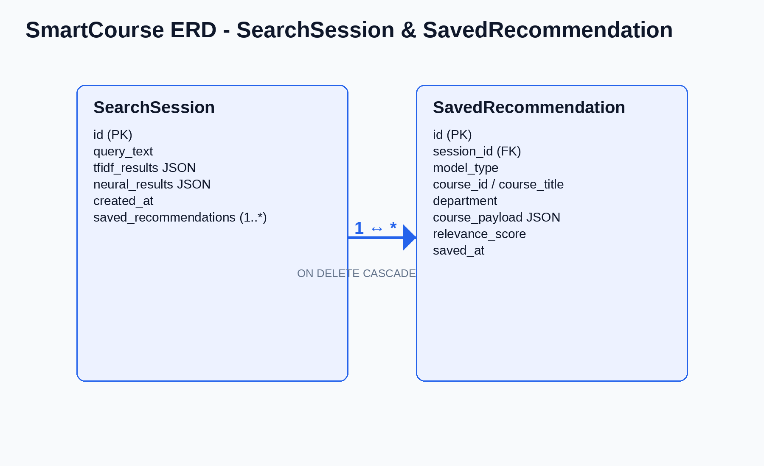
Figure: SmartCourse entity relationship diagram (SearchSession <> SavedRecommendation).
- Sequence Diagrams (To be developed using Rational Rose or any other drawing software of your choice)
Sequence Diagram SD-01: Submit Recommendation Request (UC-01)
Actors: Learner UI, Flask API, RecommendationService, TFIDFRecommender, NeuralRecommender, SQLite (HistoryService).
Flow: Learner submits preference -> API validates -> RecommendationService fans out to TF-IDF and neural engines -> results normalized -> HistoryService persists SearchSession -> API responds to UI.
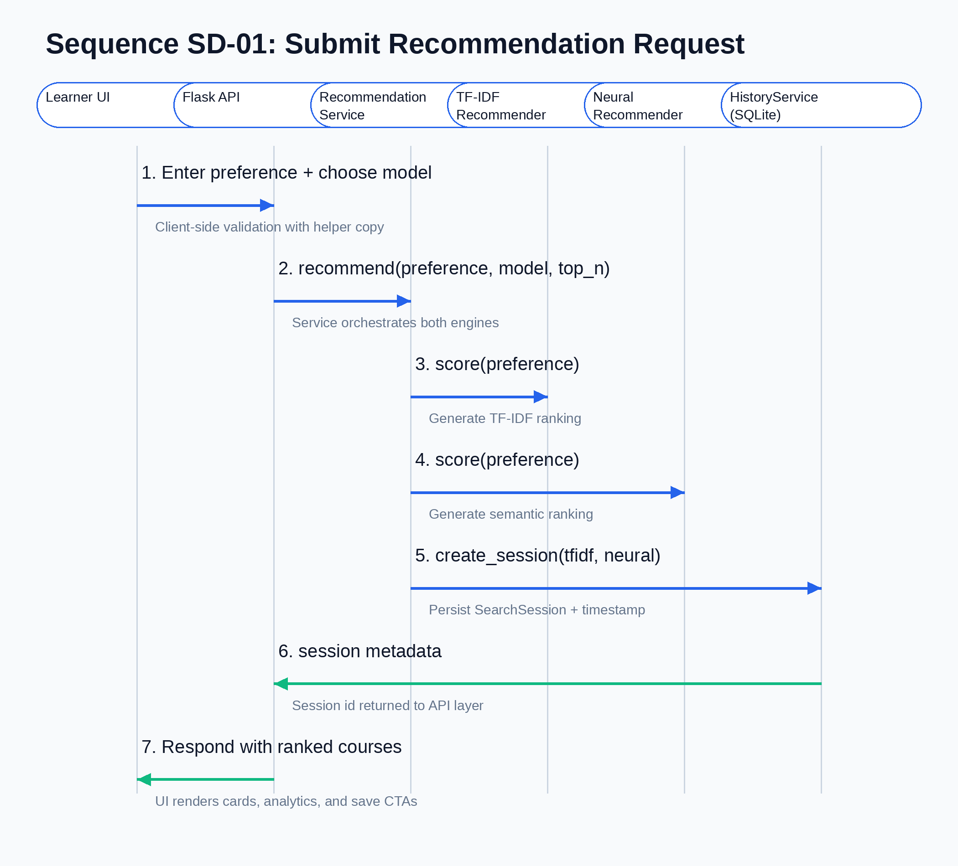
Figure: Sequence diagram SD-01 for UC-01 recommendation request.
Sequence Diagram SD-02: Save Recommendation (UC-03)
Actors: Learner UI, Flask API (/api/save), HistoryService, SQLite, Notification banner.
Flow: UI posts selected course with session_id -> API verifies payload -> HistoryService loads SearchSession -> SavedRecommendation persisted -> success response updates UI state.
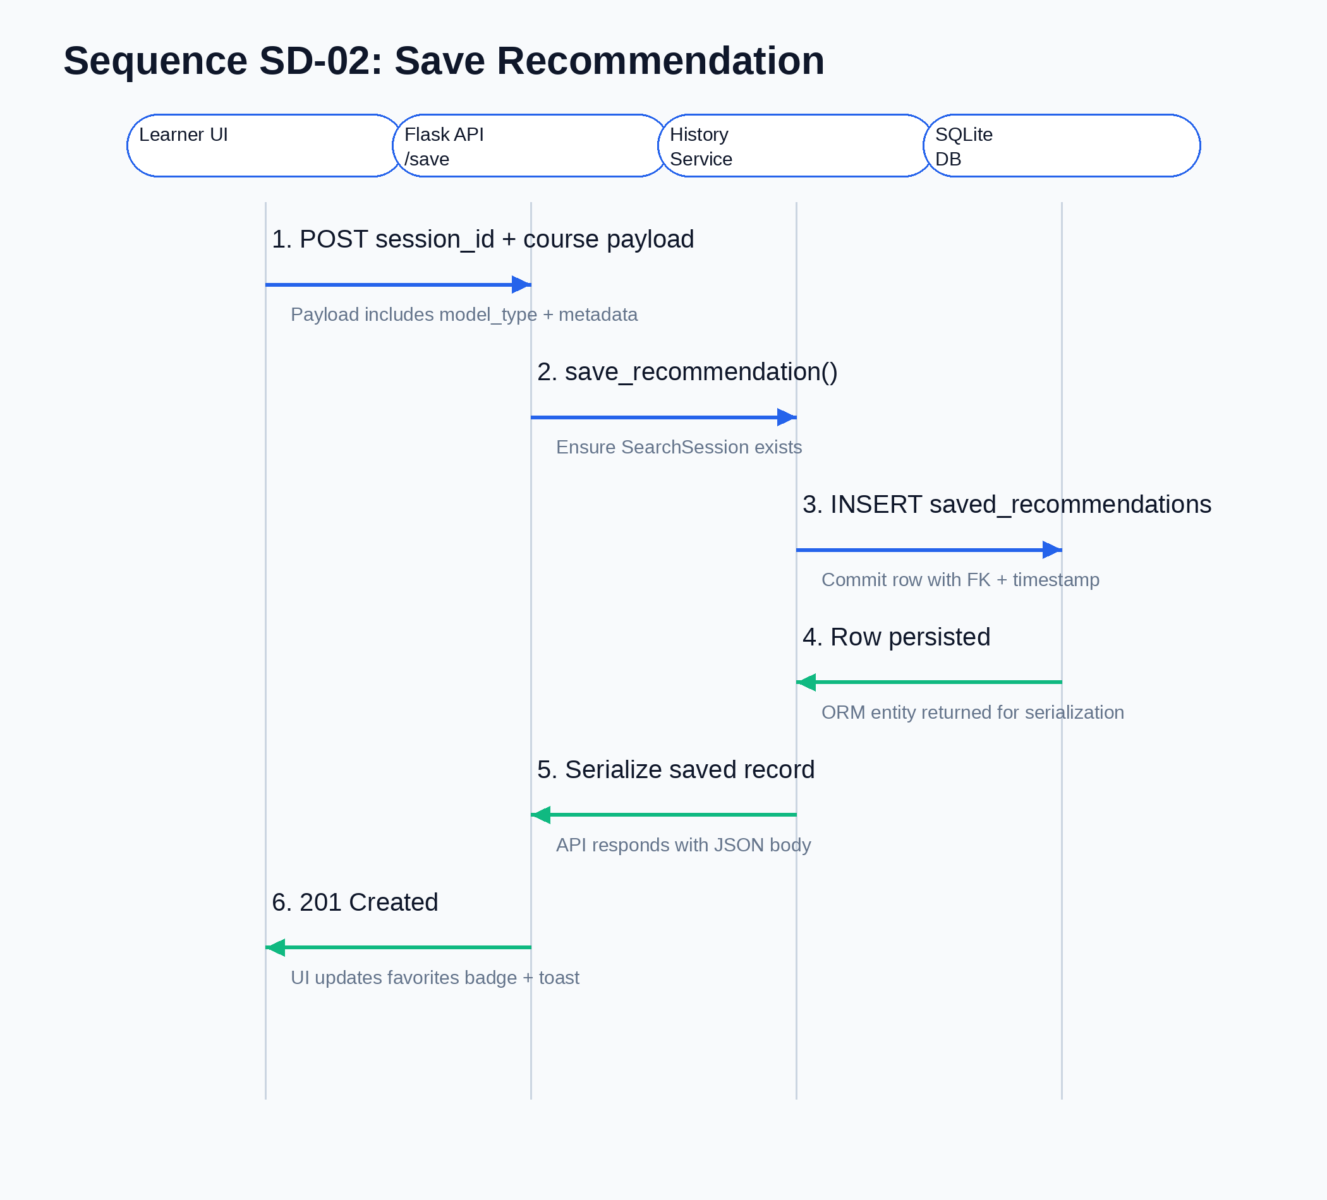
Figure: Sequence diagram SD-02 for UC-03 saving recommendations.
Sequence Diagram SD-03: Retrain and Deploy Models (UC-05)
Actors: System Administrator, CLI scripts (prepare_data.py, build_models.py), Model Registry (models/), Flask App.
Flow: Admin triggers data prep -> scripts clean dataset -> build_models.py trains TF-IDF + neural artifacts -> artifacts stored under models/ -> Admin signals Flask app to reload -> RecommendationService reloads caches.
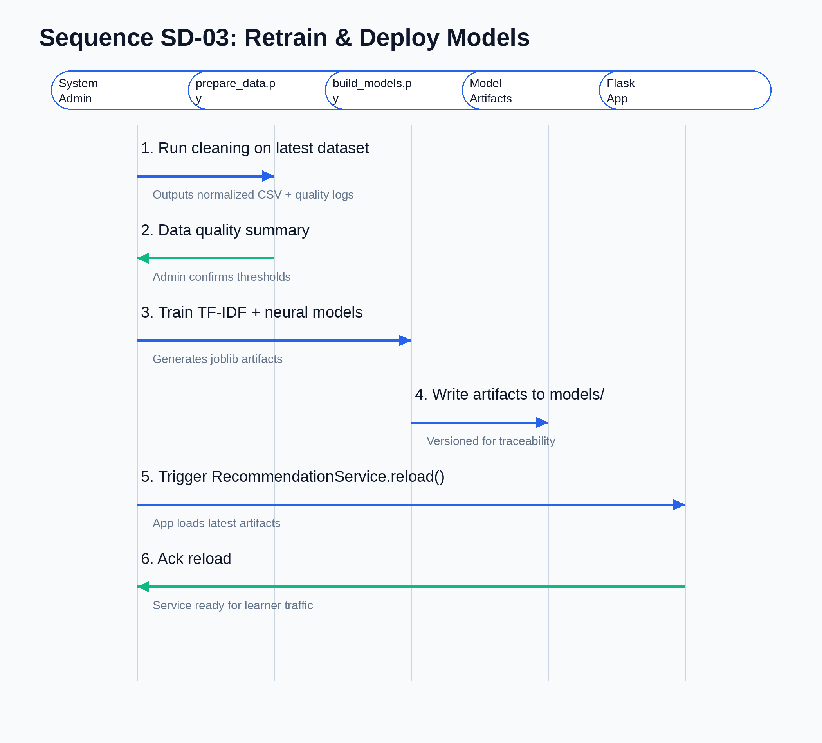
Figure: Sequence diagram SD-03 for UC-05 retraining and deployment.
- Architecture Design Diagram
SmartCourse follows a three-tier architecture comprising Presentation, Application, and Data/Model tiers.
- Presentation Tier: Bootstrap 5/Jinja UI plus REST clients sending JSON to Flask endpoints; includes comparison dashboards and admin panels.
- Application Tier: Flask app hosting API blueprint, services (RecommendationService, HistoryService), logging, and evaluation scripts. This tier enforces validation, orchestrates models, and writes analytics.
- Data & Model Tier: SQLite database for sessions/saved courses, CSV datasets under data/, and serialized TF-IDF + neural artifacts under models/.
Cross-cutting concerns such as configuration, error handling, and logging flow through extensions.py and config.py ensuring consistency across tiers.
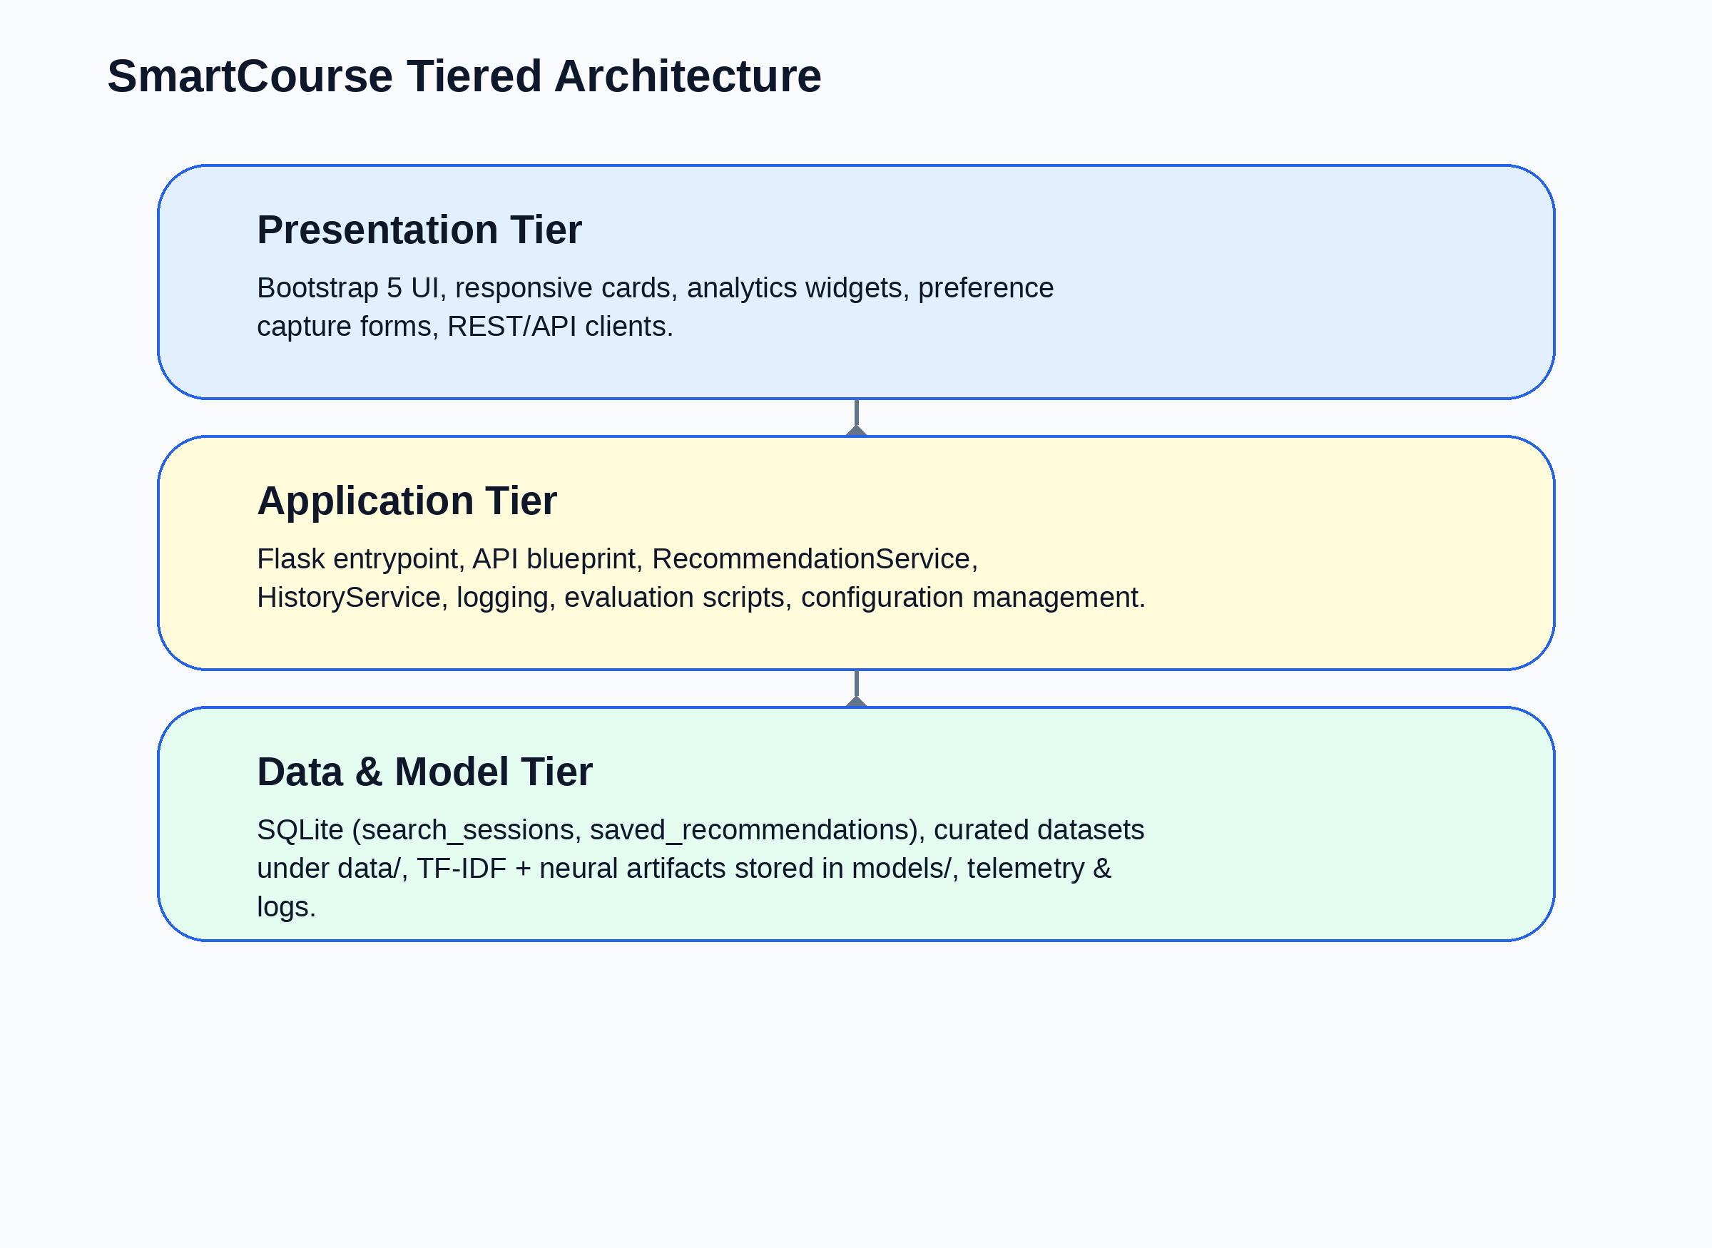
Figure: Three-tier SmartCourse architecture.
- Class Diagram

Core classes/components represented in the class diagram:
- RecommendationService aggregates TFIDFRecommender and NeuralRecommender, exposing recommend(), reload(), and normalization helpers.
- HistoryService handles SearchSession and SavedRecommendation persistence, offering create_session(), save_recommendation(), get_history(), and clearing helpers.
- SearchSession + SavedRecommendation SQLAlchemy models model the database tables with ORM relationships.
- API Blueprint classes (api.py) act as controllers mapping HTTP verbs to service calls.
- Supporting utilities such as config dataclasses and dataset/model scripts are shown as collaborators providing inputs to the service layer.
Associations emphasize that RecommendationService depends on model artifacts while HistoryService depends on SQLAlchemy db, and both are orchestrated by Flask application context.
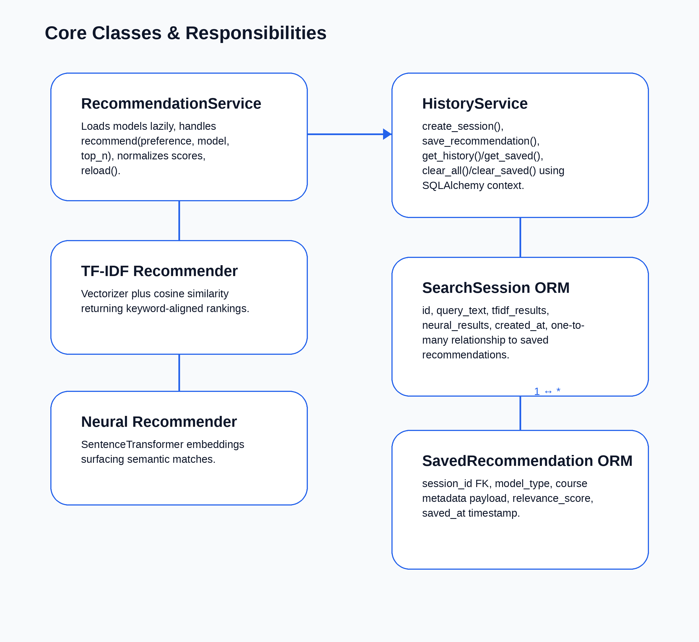
Figure: Core class relationships across services, models, and persistence objects.

- Database Design

Logical database design (SQLite) contains two first-class tables with JSON columns to keep recommendation payloads rich:
Table search_sessions: id INTEGER PK, query_text TEXT, tfidf_results JSON, neural_results JSON, created_at DATETIME DEFAULT CURRENT_TIMESTAMP.
Table saved_recommendations: id INTEGER PK, session_id INTEGER FK REFERENCES search_sessions(id) ON DELETE CASCADE, model_type TEXT, course_id TEXT, course_title TEXT, department TEXT, course_payload JSON, relevance_score REAL, saved_at DATETIME DEFAULT CURRENT_TIMESTAMP.
Indexes: saved_recommendations.session_id (BTREE) for dashboard speed; future indexes planned on created_at for archival policies.
Data types were chosen to balance analytic capabilities (JSON for payloads) with portability (SQLite native types) so the schema migrates easily to PostgreSQL later.
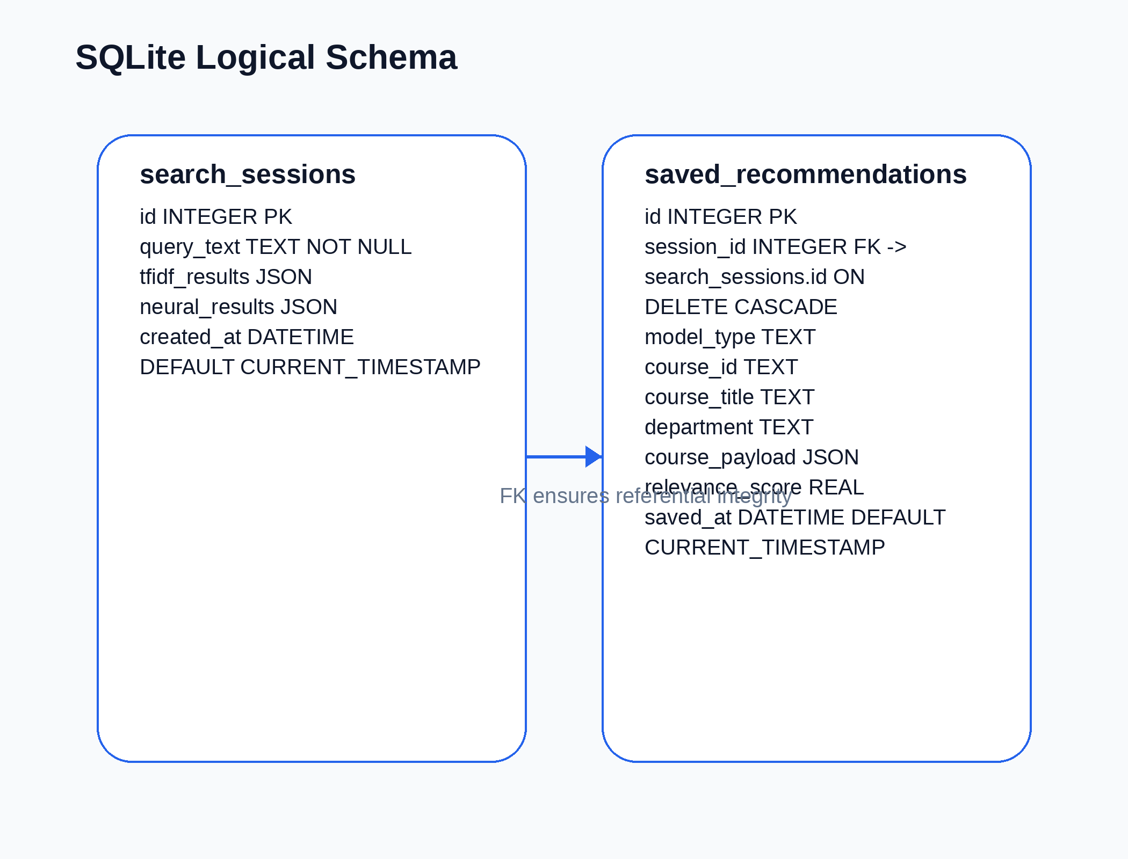
Figure: SQLite database design showing search_sessions and saved_recommendations tables.

- Interface Design

Proposed key interfaces (mockups maintained in Figma) include:
- Home & Preference Capture: hero section describing SmartCourse value, preference input field, model selector (TF-IDF / Neural / Hybrid), and quick tips.
- Recommendation & Comparison Dashboard: responsive grid of course cards with model badges, confidence bars, course metadata, and Save buttons.
- History & Favorites Panel: timeline of previous sessions, filters by model, saved recommendation table with remove actions, and analytics widgets.
- About / Methodology Page: summary of data pipeline, evaluation metrics, and contact info for the project team.
These interfaces guide development priorities and will be iterated as usability feedback arrives; final screenshots will replace these descriptions in the final report.
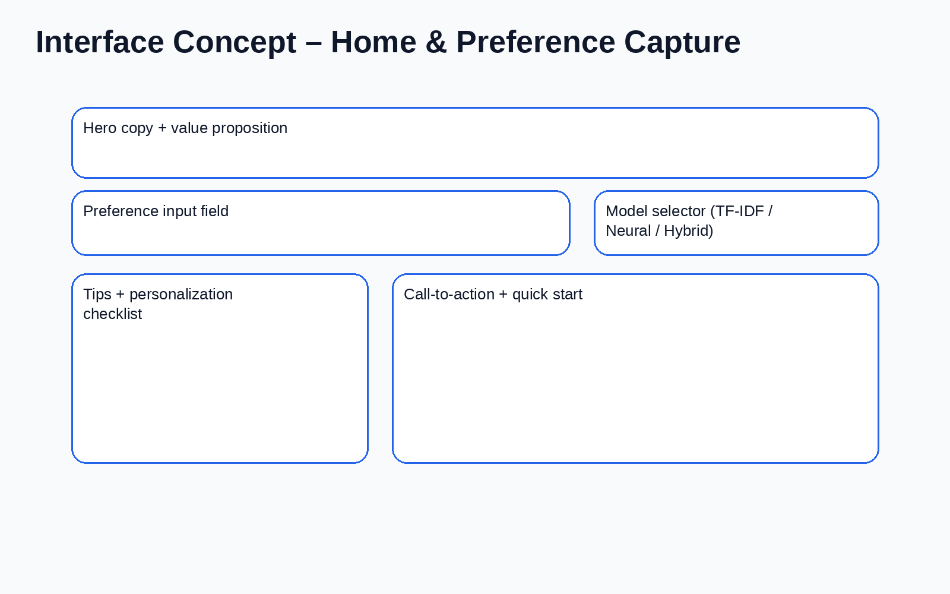
Figure: Wireframe — Home & Preference Capture view.
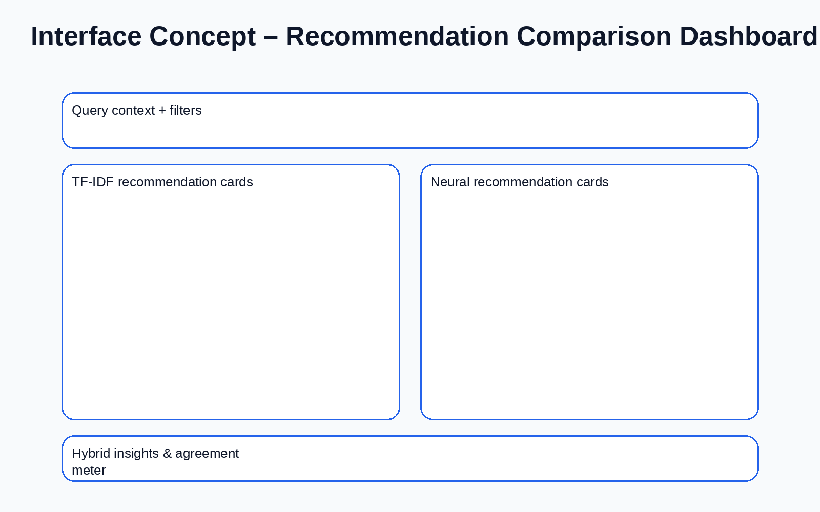
Figure: Wireframe — Recommendation Comparison Dashboard.
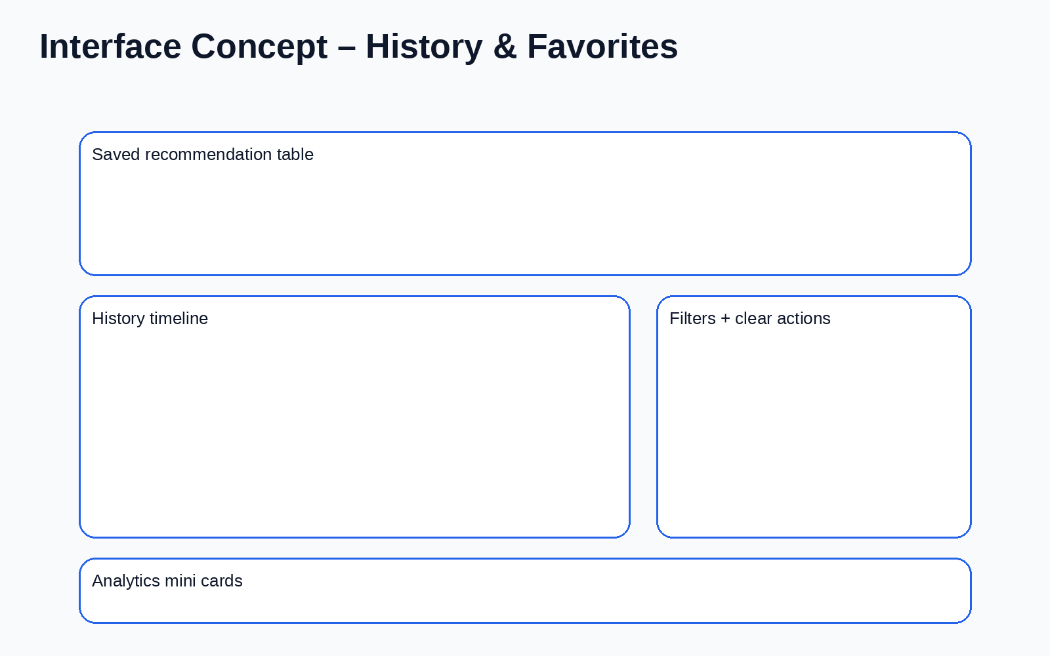
Figure: Wireframe — History & Favorites panel.

- Test Cases

Test Case ID | Related Use Case | Description | Preconditions | Test Steps | Expected Result | Status
TC-01 | UC-01 | Validate successful recommendation request via API. | Flask app running, models trained, database reachable. | 1. POST /api/recommend with valid preference and model=hybrid.  2. Observe response. | Response 200 with TF-IDF and neural arrays, SearchSession stored. | Planned
TC-02 | UC-01 | Handle empty preference validation. | Flask app running. | 1. POST /api/recommend with preference="".  2. Observe response. | API returns 400 with validation error; no session persisted. | Planned
TC-03 | UC-03 | Persist saved recommendation. | Existing session_id from TC-01. | 1. POST /api/save with session_id and course payload.  2. Query /api/history. | API returns 201; saved_recommendations contains new entry tied to session. | Planned
TC-04 | UC-05 | Reload models after retraining. | New artifacts produced under models/. | 1. Run scripts/build_models.py.  2. Call RecommendationService.reload().  3. Issue /api/recommend request. | Service reloads without restart; subsequent calls use fresh artifacts. | Planned

